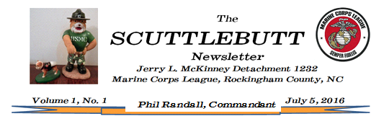
December 3, 2017

Volume 2, No. 12

Volume 2, No. 12
December 1, 2017

Well, the 242nd Marine Corps Birthday Ball is now history. What a night!! What can I say? The ladies looked lovely, the men were handsome in their Marine Corps League red coats, the tables were beautiful (thanks to Norma Kelly), the food was delicious (thanks to Rene Atkins), the birthdday cake was gorgeous, and the music and speeches were inspiring. We had two birthday cakes that were identical. One was consumed at the Ball and we are going to enjoy the other one at the Christmas party on December 14th. Debbie Lambert was voted PFC Jerry L. McKinney Detachment 1232 MCL 2018 Woman Of The Year and Jerry Welch was selected 2018 Marine Of The Year. It was an exciting night and one of our very best Birthday Balls!

You are invited to the Marine Corps League Christmas party on Thursday, December 14, 2017 at
1800 hours. The party will be held at the Agricultural Center in Wentworth, N.C. Bobby Tilley has generously offered to cater our party again this year. (Thank you, Bobby.) Feel free to bring your favorite holiday finger food and/or your favorite dessert. We will be playing “Dirty Santa,” so please select something with a $10.00 value to exchange. Also, in support of the Marine Corps Toys For Tots, we are requesting that you bring an unwrapped toy to be donated to this program. We are looking forward to sharing some holiday cheer with you, so please plan to attend!

Note: The Scuttlebutt is printed and mailed monthly prior to the regularly scheduled meeting of the Pfc. Jerry L. McKinney Detachment. Regular and associate members of the detachment will receive a copy automatically unless otherwise notified. Prospective members and others can be added to the mailing list upon request by calling 336-627-4505 or writing to: Editors of The Scuttlebutt are Jim and Ann Clark at 425 Beagle Club Road, Stoneville, NC 27408. Comments or suggestions are also welcomed.

(Over)
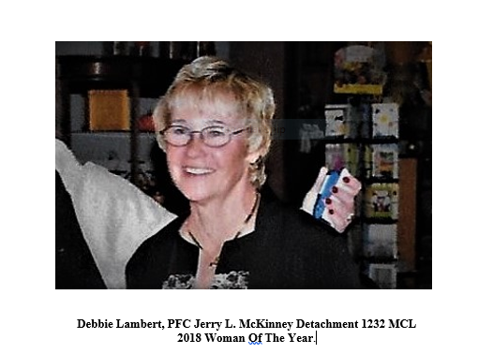

Semper Fi!

